**Level 12 to 13:**

*Level Goal:*

The password for the next level is stored in the file **data.txt**, which is a hexdump of a file that has been repeatedly compressed. For this level it may be useful to create a directory under /tmp in which you can work using mkdir. For example: mkdir /tmp/myname123. Then copy the datafile using cp, and rename it using mv (read the manpages!)

*Commands used:*

ls

cat

mkdir – make a directory

xxd – make a hexdump or convert hexdump to binary

file

gzip – compress or expand files

bzip2 – file compressor (block sorting)

cp – copy files and directories

mv – rename files

exit

*Solution:*

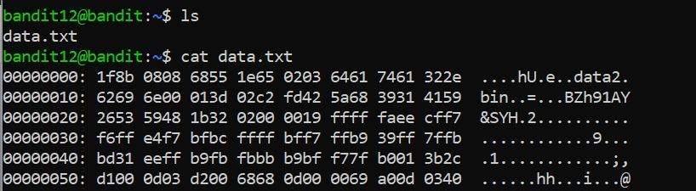

1. looked into the provided file using cat. tried to reverse hexdump the file given but did not have permission to do so
2. made a new directory named tmp/new_dir and copied all the data from the main directory into this one. then moved all the data from data.txt to a file named ‘data’.

bandit12@bandit:/tmp/new_dir$ cp ~/data.txt

bandit12@bandit:/tmp/new_dir$ ls

data.txt

bandit12@bandit:/tmp/new_dir$ mv data.txt data

bandit12@bandit:/tmp/new_dir$ ls  
 data

1. it started getting too messy so I reset the server and exited in the hopes of trying again and remaking a new directory (which is why there is no screenshot of the above commands since I forgot reset would make all of it disappear)
2. unfortunately, got the output ‘cannot create directory: file exists’ on both my names (random and random_dir) so I decided to try and enter a dir i already knew existed (new_dir) 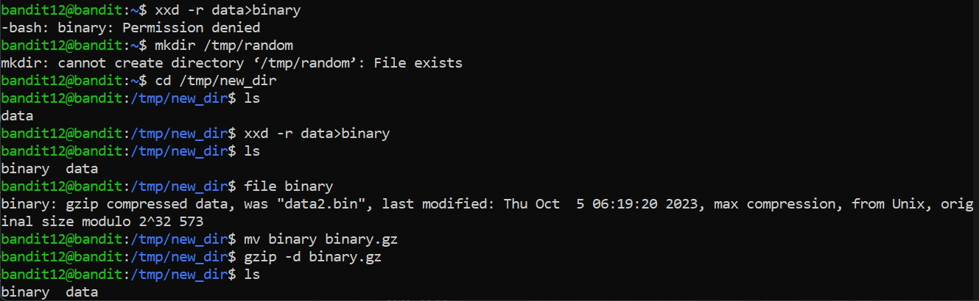
3. used cd to enter the new directory new_dir and look at the file there (data). then used the xxd command on it, but added a flag -r to make sure it understood to convert the data to binary
4. when we look into the directory again we can see two files now: data and binary
5. decided to look at binary, used file command, which told me that binary was gzipped. changed the file extension to fit the requirements to unzip it (changed the suffix to .gz), and used the gzip command with -d flag to decode it.
6. check on the binary file again and this time it’s a bzip2 of compressed data. decoded that directly which led to another gzip file

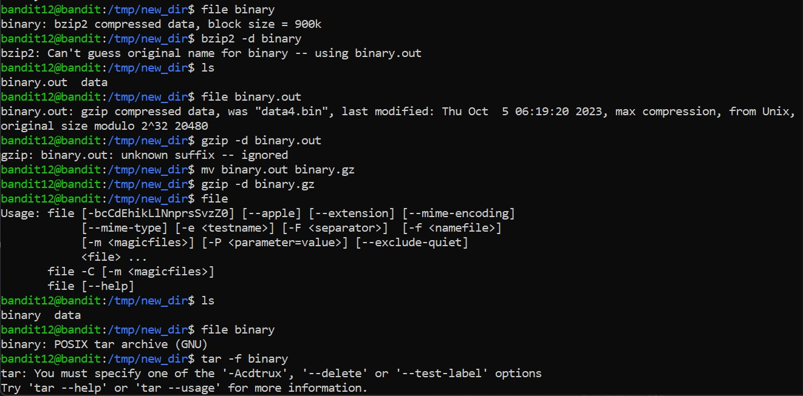

1. repeated steps 7 and 8, along with the tar command with the -xf flag, to keep breaking into the zipped files until finally we get the output ‘data8.bin: ASCII text’.

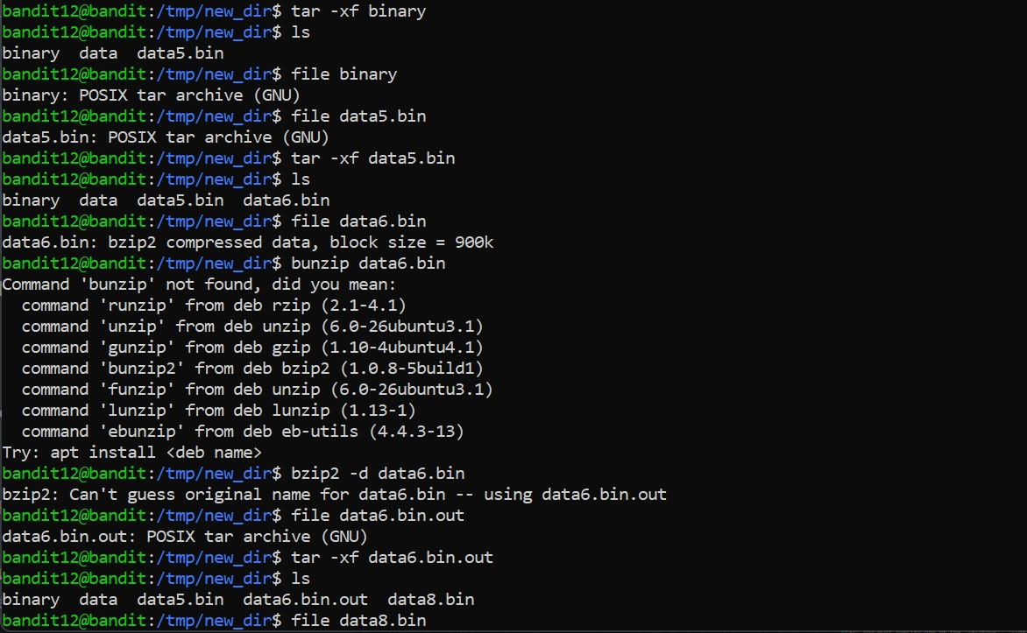

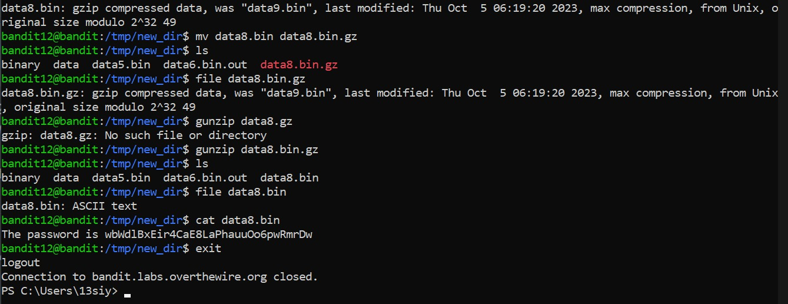

1. cat data8.bin to find the password required, exit and log onto the next level

*Links used:*

<https://linuxize.com/post/gzip-command-in-linux/?source=post_page-----2ec761a88907-------------------------------->

<https://linuxize.com/post/how-to-create-and-extract-archives-using-the-tar-command-in-linux/?source=post_page-----2ec761a88907-------------------------------->

**Level 13 to 14:**

*Level Goal:*

The password for the next level is stored in **/etc/bandit_pass/bandit14 and can only be read by user bandit14**. For this level, you don’t get the next password, but you get a private SSH key that can be used to log into the next level. **Note:** **localhost** is a hostname that refers to the machine you are working on

*Commands used:*

ls

ssh – OpenSSH remote login client

exit

*Solution:*

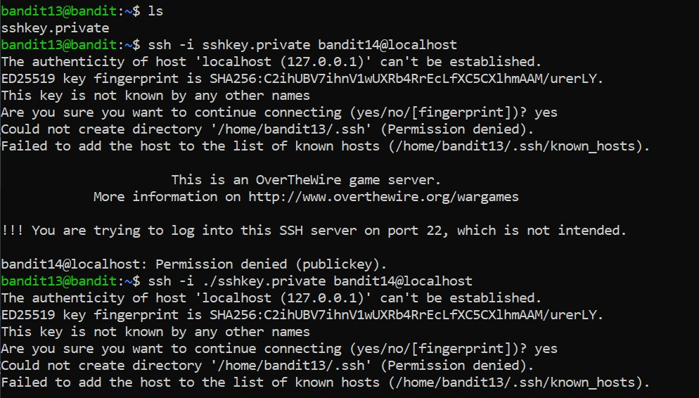

1. looked into the server and found the key to access the next level
2. tried to log into the next server using the ssh command to no avail, twice, both using the flag -i to recognize the name of the key
3. finally got it by adding the port number 2220 to the command and entered the next level

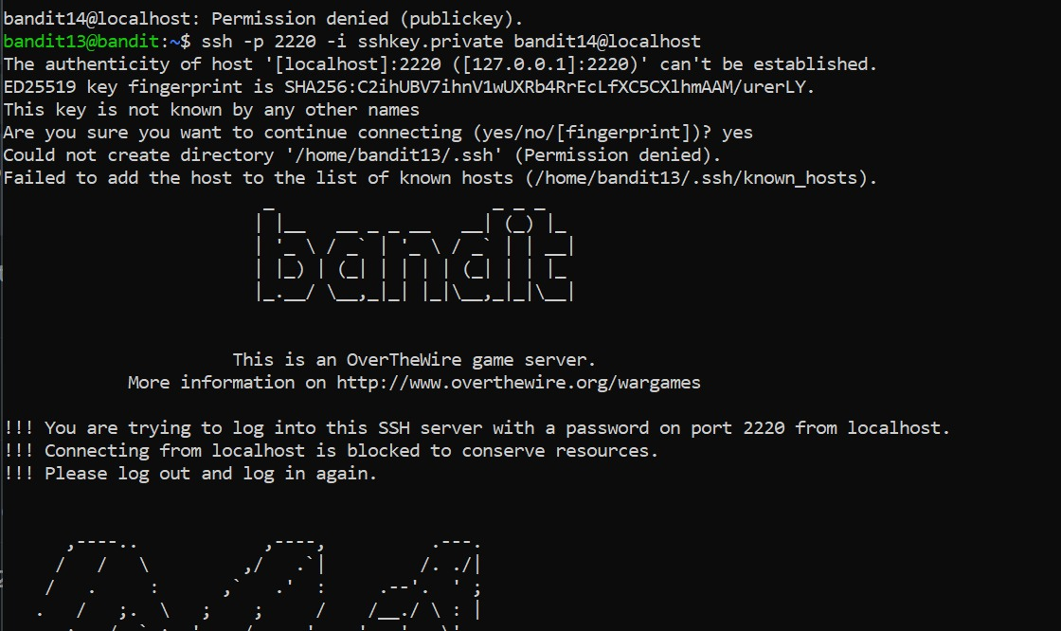

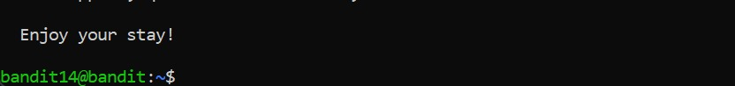

*Links used:*

<https://help.ubuntu.com/community/SSH/OpenSSH/Keys>

**Level 14 to 15:**

*Level Goal:*

The password for the next level can be retrieved by submitting the password of the current level to **port 30000 on localhost**.

*Commands used:*

ls

cat

nc – TCP/IP swiss army knife

exit

*Solution:*

1. used the cat command to see what is in the file mentioned, found the password to enter level 14.
2. opened a manual on nc to find out how to add the port key to connect to the service
3. successfully connected to the service but accidentally pressed the enter button and got a ‘Wrong!’ message.
4. Entered the correct password and found the password for the next level, and exited the current level

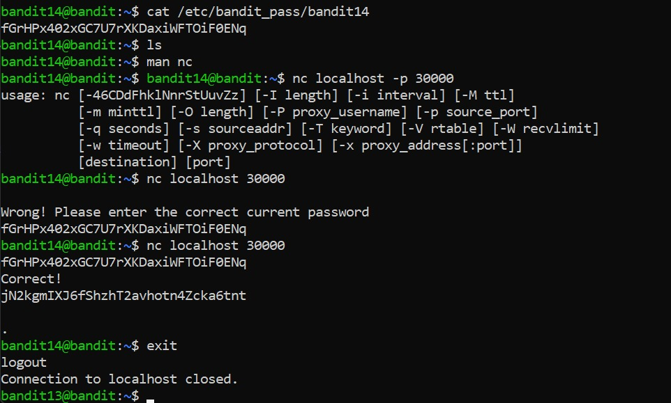

*Links used:*

<https://linuxize.com/post/netcat-nc-command-with-examples/?source=post_page-----9f0fd934a9bc-------------------------------->

**Level 15 to 16:**

*Level Goal:*

The password for the next level can be retrieved by submitting the password of the current level to **port 30001 on localhost** using SSL encryption

*Commands used:*

ls

cat

nc – TCP/IP swiss army knife

exit

*Solution:*

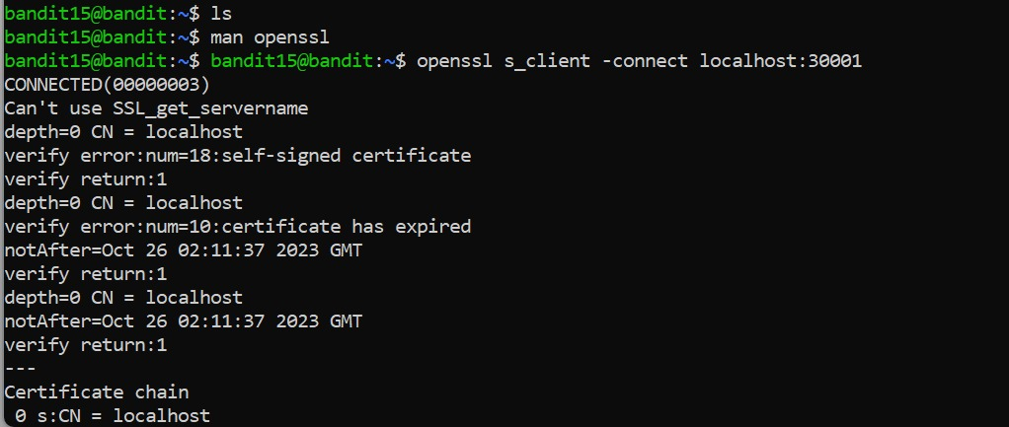

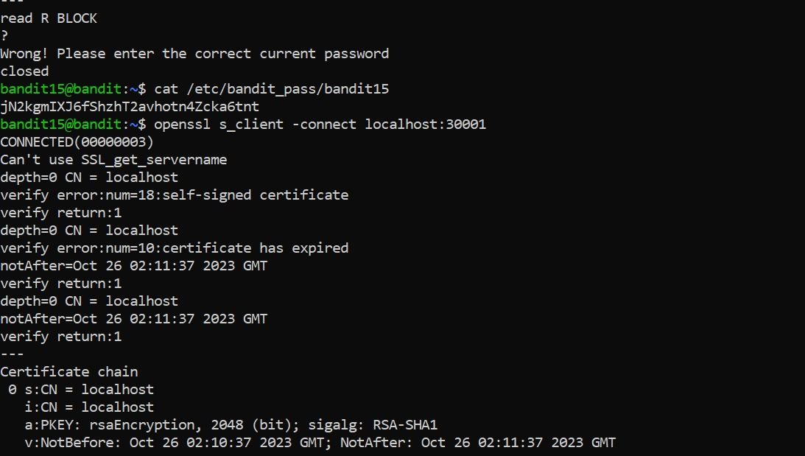

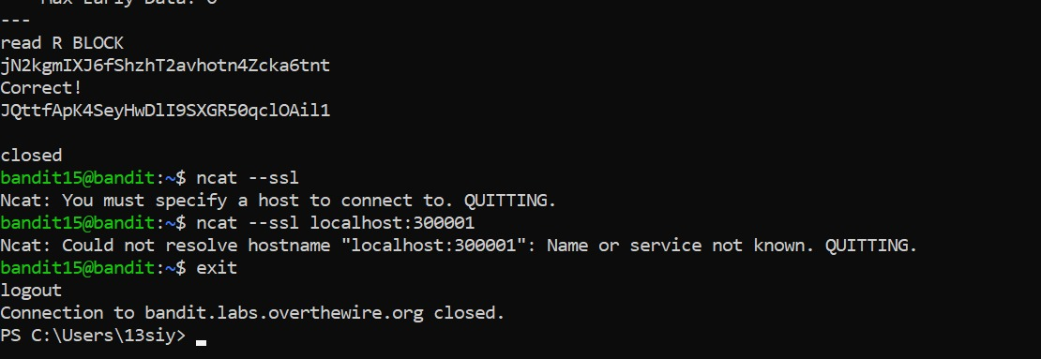

1. used ls to no output then opened a manual on openssl, used the connect flag to connect to the port given in the question
2. got an output with no instructions so entered a question mark to see the result
3. output was ‘Wrong! Enter the correct password’ and hence, decided to try the same thing as last level
4. got the correct password by rereading the file /etc/bandit_pass/bandit15
5. retried step 1, and this time entered the password and got the password for the next level.
6. Tried a different method using ncat --ssl which did not work (which I now see is because I was entering the wrong port), so decided to just exit out of the server

*Links used:*

<https://en.wikipedia.org/wiki/Transport_Layer_Security#SSL_1.0,_2.0,_and_3.0>

**Level 16 to 17:**

*Level Goal:*

The credentials for the next level can be retrieved by submitting the password of the current level to **a port on localhost in the range 31000 to 32000**. First find out which of these ports have a server listening on them. Then find out which of those speak SSL and which don’t. There is only 1 server that will give the next credentials, the others will simply send back to you whatever you send to it.

*Commands used:*

ls

cat

touch – tested a name to see if the file or folder is empty

nmap - network exploration tool and security / port scanner

ssh

openssl – openssl command line tool

s_client – tls client program

exit

*Solution:*

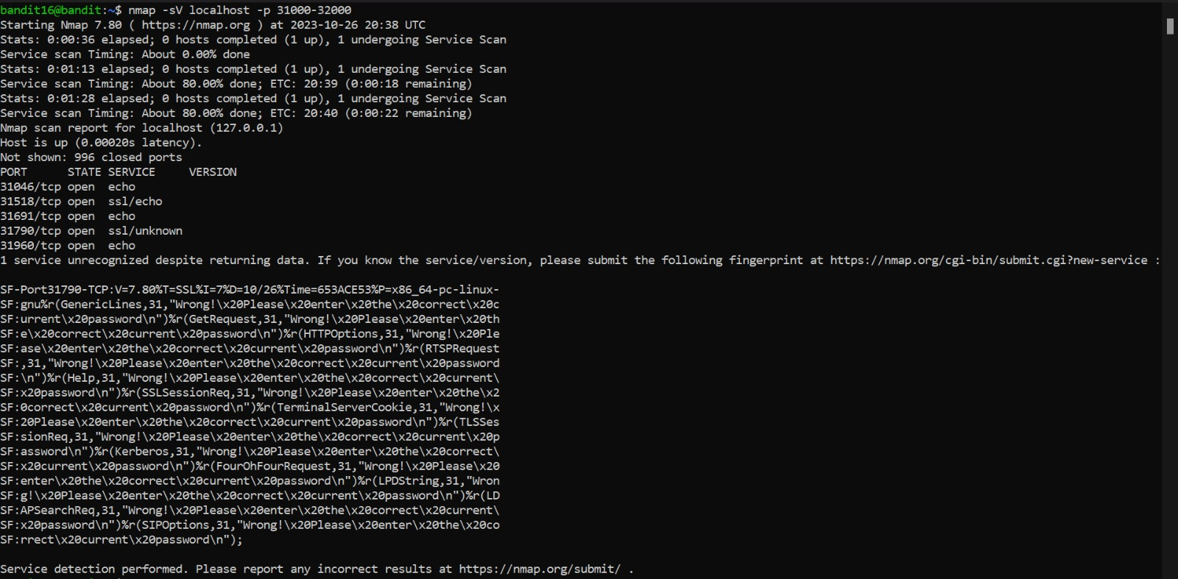

1. the service that we need is running in the range 31,000–32,000, we can find all services in that range using nmap command with the -p flag is used to specify the ports and the -sV flag to identify the versions of the services
2. if we look at the results more closely, we see that on port 31790 is specified outside the “wrong! Please enter the correct passwords!”
3. using openssl and s_client with the connect flag to connect to localhost:31790, and entered the password that I used to enter into this level
4. here we get an RSA private key. decided to look up how to use RSA keys and found out you can use both vim and nano to copy rsa private keys, and store them in a file
5. touched a tmp directory to see if I could cd into it, and proceeded to enter into it to store the key into a file ‘private.key’ using nano command.

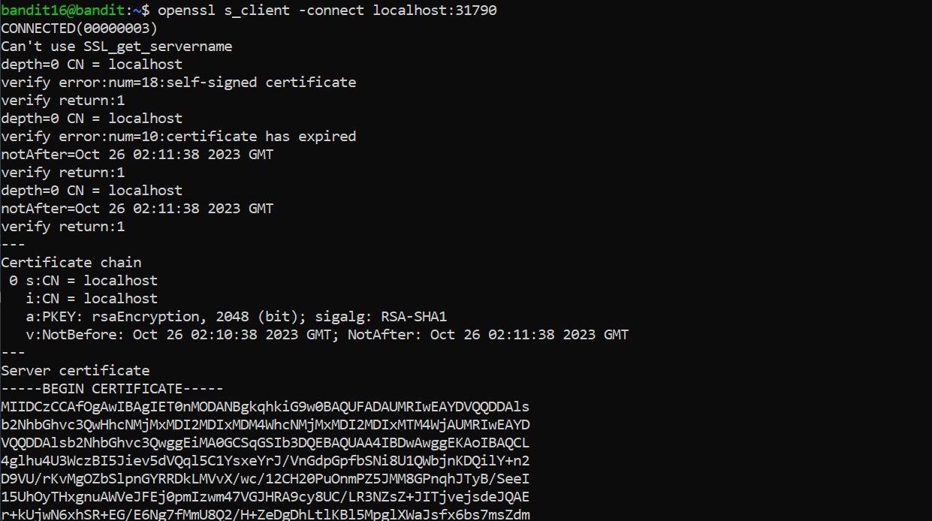

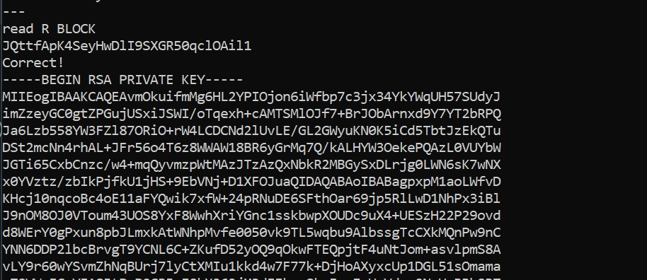

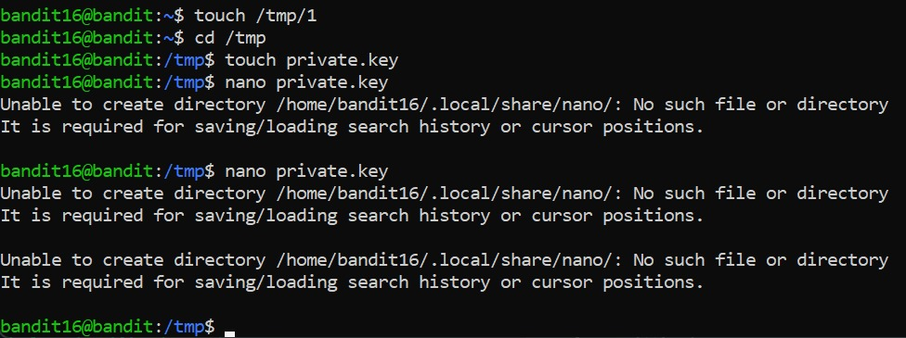

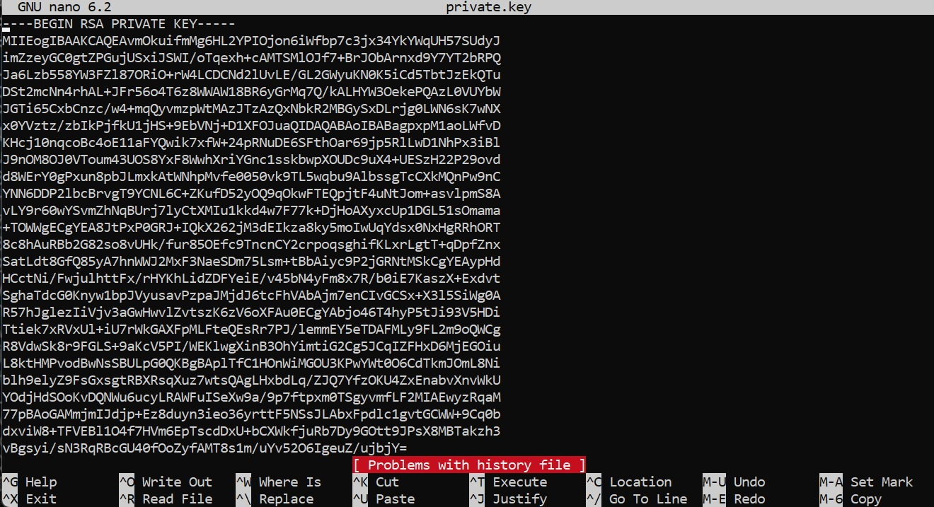

1. used the ls command with -l flag to look at the permissions of the file since that proved to be a problem before in a previous level, changed the permissions to 400 to make it less public
2. unfortunately, this key did not work and I tried to do the same thing over and over (did not take screenshot as it was all futile attempts with no avail.)
3. looked at every single walkthrough I could find and still did not realize what I was doing wrong

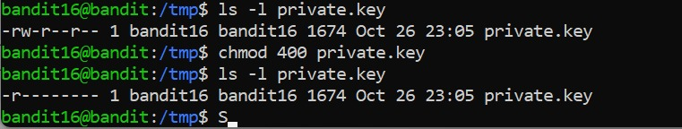

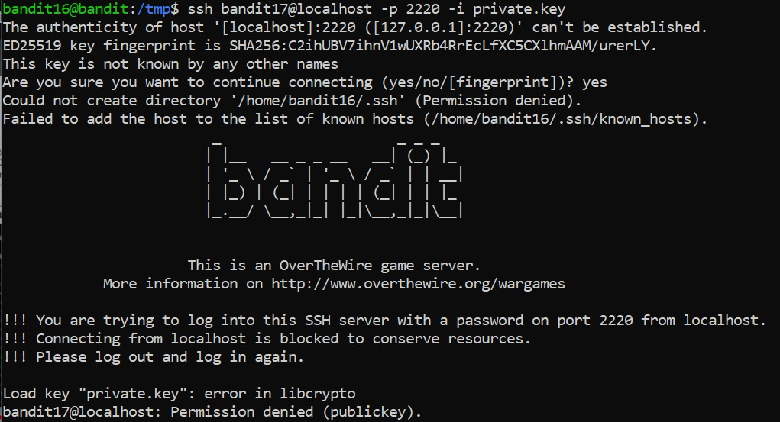

1. tried again the next day, this time by changing the permissions to 600 instead of 400 or 700 like I was trying before
2. this finally worked and I was able to log into the bandit17 server and get the password using cat /etc/bandit_pass/bandit17

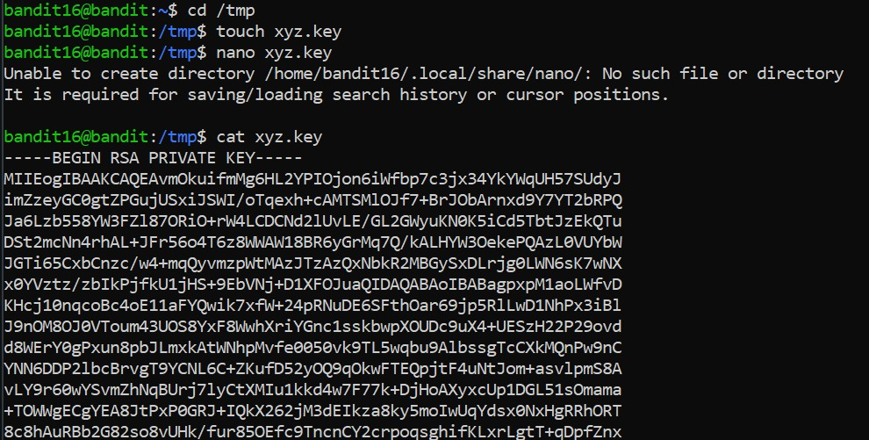

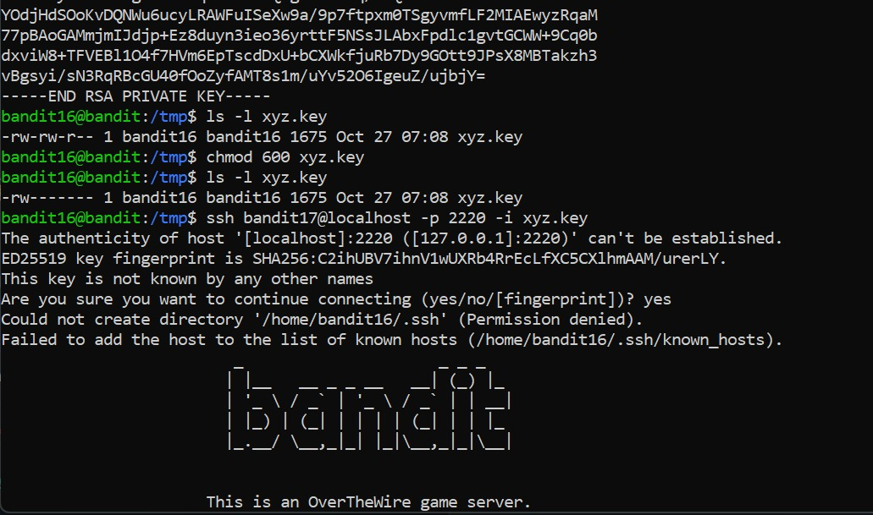

*Links used:*

<https://youtu.be/CQ14LbpQofQ?si=P7MfWw7ADitZ4udo>

<https://stackoverflow.com/questions/75935815/stuck-on-16-17-level-of-overthewire-bandit-game>

<https://en.wikipedia.org/wiki/Port_scanner>

<https://www.ssldragon.com/blog/what-is-openssl/>

<https://www.geeksforgeeks.org/practical-uses-of-openssl-command-in-linux/>

<https://www.geeksforgeeks.org/nmap-command-in-linux-with-examples/>

<https://www.openssl.org/docs/man1.1.1/man1/openssl-s_client.html#:~:text=The%20s_client%20command%20implements%20a,diagnostic%20tool%20for%20SSL%20servers>

**Level 17 to 18:**

*Level Goal:*

There are 2 files in the home directory: **passwords.old and passwords.new**. The password for the next level is in **passwords.new** and is the only line that has been changed between **passwords.old and passwords.new**

*Commands used:*

ls

cat

diff – compares text files

exit

*Solution:*

1. used cat to get the password for the level similar to level 15.
2. used ls to see the files in directory
3. looked into one of the files using cat and found a block of text

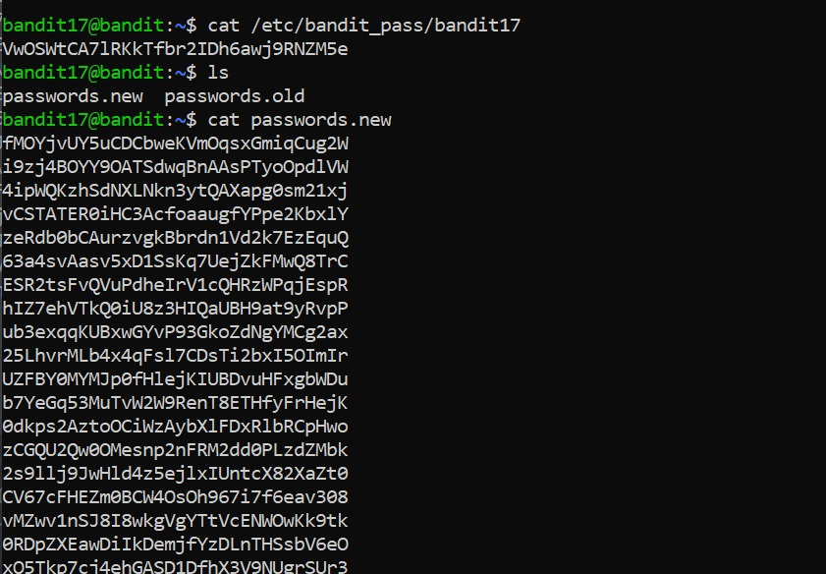

1. looked up how to figure out what’s the difference between two files, found the diff command
2. used the diff command to find the two differences in the file
3. stored both the files in my notepad but used only the ‘passwords.new’ password to log onto the next level according to the question

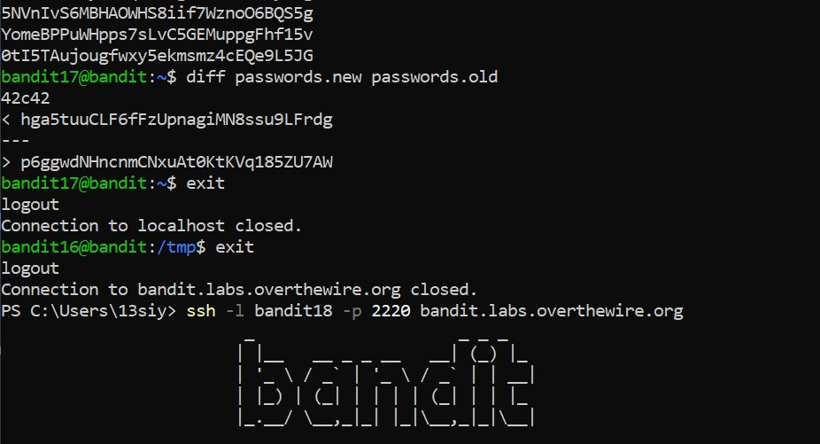

*Links used:*

<https://www.ibm.com/docs/en/aix/7.2?topic=files-comparing-diff-command>

**Level 18 to 19:**

*Level Goal:*

The password for the next level is stored in a file **readme** in the home directory. Unfortunately, someone has modified **.bashrc** to log you out when you log in with SSH.

*Commands used:*

ls

cat

diff – compares text files

exit

*Solution:*

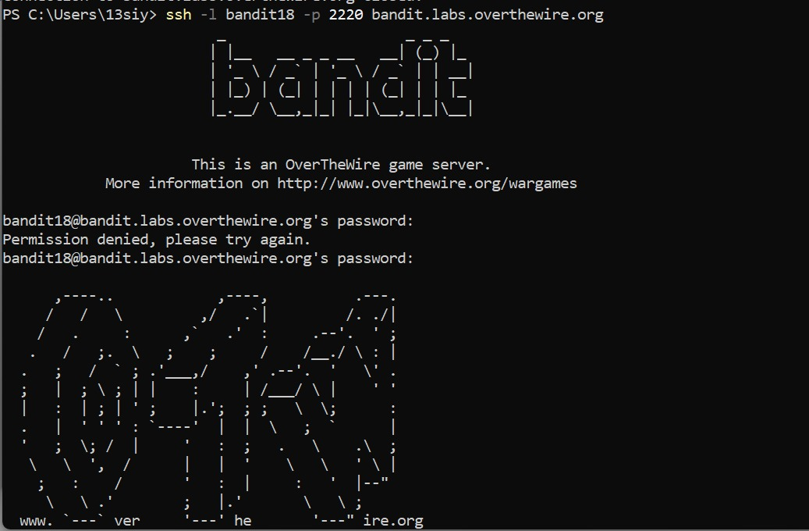

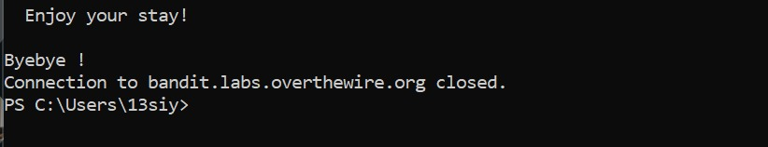

Method 1:

1. saw that I can’t log onto the localhost even with the right password
2. decided to look up how to circumvent the problem
3. decided to execute commands within the ssh command
4. used ls within the ssh command and found the readme file
5. used cat readme within the ssh command once more and found the password

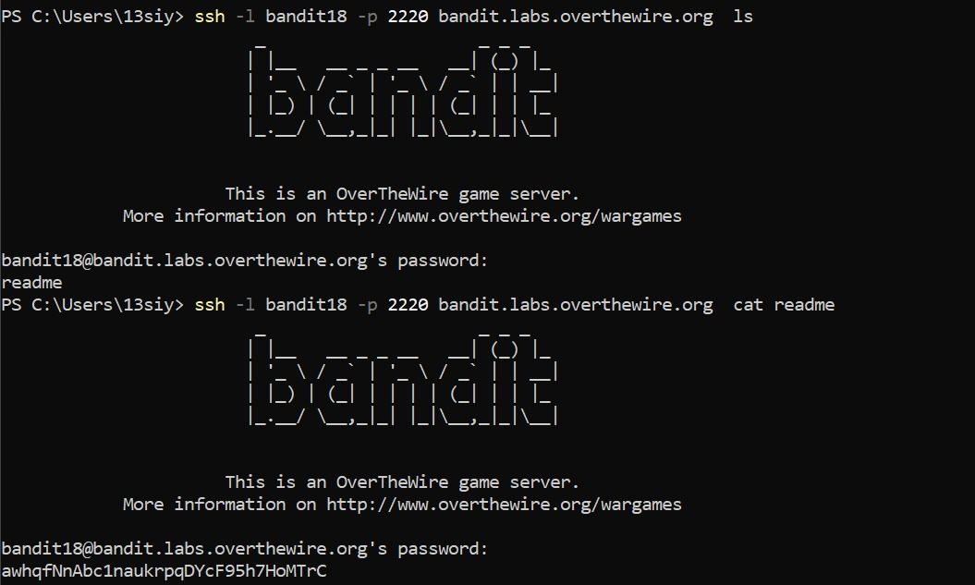

Method 2:

1. while looking up ways to circumvent the problem, realized that I could also use a preset shell to log into the server, with a -t flag to specify that the shell will be used to log into the server
2. decided to use the /bin/sh shell since that was the one that seemed most common in the details of all the shells stored in linux
3. further, used ls and cat after successfully logging into the server to find the password and exited the server

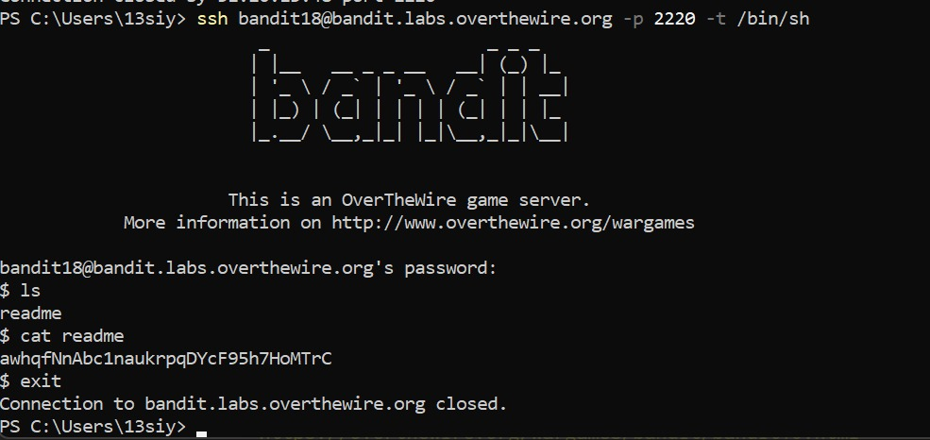

*Links used:*

<https://www.cyberciti.biz/faq/unix-linux-execute-command-using-ssh/>

<https://serverfault.com/questions/162018/force-ssh-to-use-a-specific-shell>

<https://medium.com/@JAlblas/tryhackme-what-the-shell-walkthrough-6c0ebe8f854e>

**Level 19 to 20:**

*Level Goal:*

To gain access to the next level, you should use the setuid binary in the homedirectory. Execute it without arguments to find out how to use it. The password for this level can be found in the usual place (/etc/bandit_pass), after you have used the setuid binary.

*Commands used:*

ls

cat

./<filename> - runs an executable file

id - confirm the identity of a specified Linux user

exit

*Solution:*

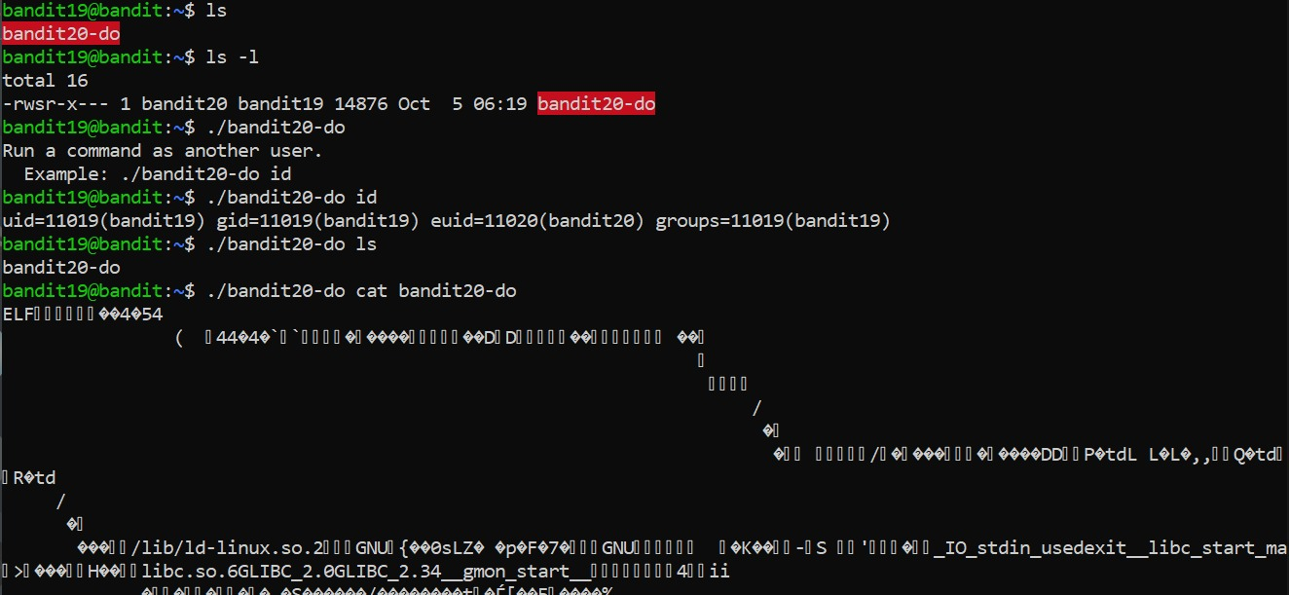

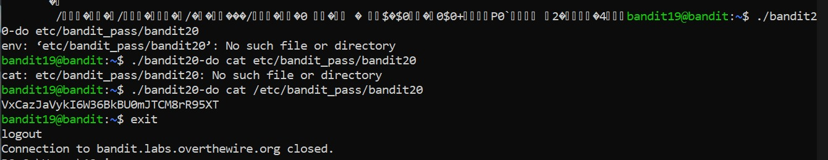

1. used ls to find an executable file bandit20-do
2. looked up how to execute executable files
3. found the example to run id command inside the executable file
4. we see that there’s an executable uid bandit20 within the file and we can use that file to find the passkey similar to levels 15 and 17, using cat of /etc/bandit_pass/bandit20
5. we find the password and exit out of the server to access the next level

*Links used:*

<https://www.atlantic.net/vps-hosting/how-to-use-the-id-command-in-linux/>

<https://www.cbtnuggets.com/blog/technology/system-admin/linux-file-permissions-understanding-setuid-setgid-and-the-sticky-bit>

**Level 20 to 21:**

*Level Goal:*

There is a setuid binary in the homedirectory that does the following: it makes a connection to localhost on the port you specify as a commandline argument. It then reads a line of text from the connection and compares it to the password in the previous level (bandit20). If the password is correct, it will transmit the password for the next level (bandit21).

*Commands used:*

ls

cat

./<filename>

nc – arbitrary TCP and UDP connections and listens

exit

*Solution:*

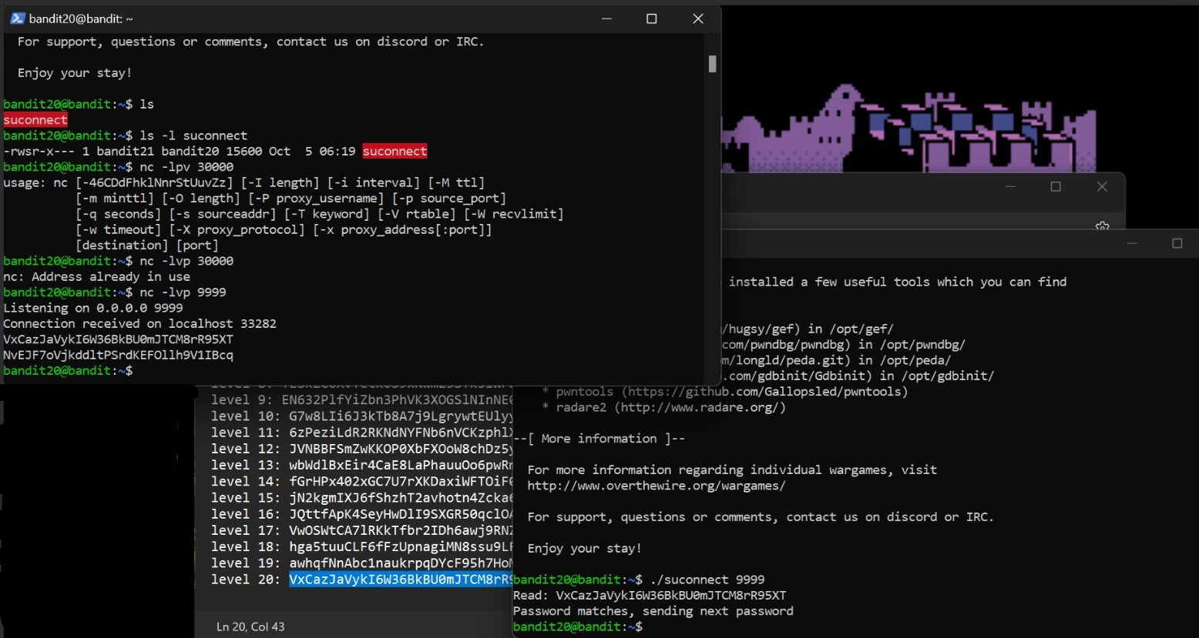

1. used ls to find suconnect executable file and looked at its properties using the -l flag
2. looked up how to use the netcat command and also went through a few tutorials of the command, linked below
3. decided to use the listening and verbose flags and connect to an arbitrary source port ‘9999’
4. opened a new window of powershell and connected to bandit20 on that window as well, saw a message pop up ‘connection received on localhost 33282’.
5. reread the question as I was a bit lost at this point and saw ‘*compares it to the password in the previous level*’, so I enter the password I used to log onto this level
6. the secondary window automatically read and returned the password for the next level
7. closed the secondary window and exited the server in the main window to access the next level

*Links used:*

<https://youtu.be/Wzc9cgEar7g?si=H57z2LMg8bCWWg3X>

<https://linuxize.com/post/netcat-nc-command-with-examples/?source=post_page-----cc769247866a-------------------------------->

**Level 21 to 22:**

*Level Goal:*

A program is running automatically at regular intervals from **cron**, the time-based job scheduler. Look in **/etc/cron.d/** for the configuration and see what command is being executed.

*Commands used:*

ls

cat

./<filename>

nc – arbitrary TCP and UDP connections and listens

exit

*Solution:*

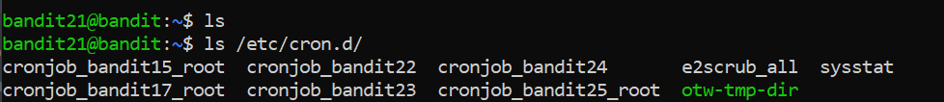

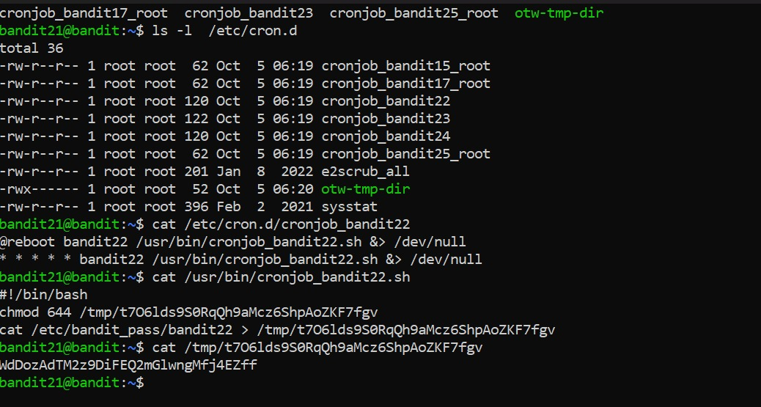

1. used ls twice, once with the mentioned address /etc/cron.d
2. saw that cronjob_bandit22, cronjob_bandit23 and cronjob_bandit24 all didn’t have a root suffix after it, so I decided to poke around each of them starting with bandit22
3. used cat command on the address for cronjob_bandit22 and got a bit of a confusing output
4. realized I got another address and decided to pursue it with another cat command only to get yet another output, this time directly pointing to an address where the password is usually stored (like in level 15 and 17)
5. used a cat command on the address given and found the password
6. exited the server and accessed the next level

*Links used:*

<https://www.tecmint.com/11-cron-scheduling-task-examples-in-linux/?source=post_page-----6cb782b4b17b-------------------------------->

<https://www.computerhope.com/unix/ucrontab.htm?source=post_page-----6cb782b4b17b-------------------------------->

*Passwords used:*

level 12: JVNBBFSmZwKKOP0XbFXOoW8chDz5yVRv

level 13: wbWdlBxEir4CaE8LaPhauuOo6pwRmrDw

level 14: fGrHPx402xGC7U7rXKDaxiWFTOiF0ENq

level 15: jN2kgmIXJ6fShzhT2avhotn4Zcka6tnt

level 16: JQttfApK4SeyHwDlI9SXGR50qclOAil1

level 17: VwOSWtCA7lRKkTfbr2IDh6awj9RNZM5e

level 18: hga5tuuCLF6fFzUpnagiMN8ssu9LFrdg p6ggwdNHncnmCNxuAt0KtKVq185ZU7AW

level 19: awhqfNnAbc1naukrpqDYcF95h7HoMTrC

level 20: VxCazJaVykI6W36BkBU0mJTCM8rR95XT

level 21: NvEJF7oVjkddltPSrdKEFOllh9V1IBcq

level 22: WdDozAdTM2z9DiFEQ2mGlwngMfj4EZff